Assignment no .10
Graph

Course Name : Data Structures-I
Course Code : CS2301
Div : SEDA-B
Student Name : Yashraj Dinesh Hande
Roll Number : 18
Date of Submission : 25/11/2025
Problem 1: Write a Program to implement Kruskal’s algorithm to find the minimum spanning tree of a user defined graph. Use Adjacency Matrix to represent a graph.

CODE:
#include <iostream>
#include <vector>
#include <algorithm>
using namespace std;

// Structure to represent an edge
struct Edge {
int u, v, weight;
};

// Disjoint Set Union (Union-Find) class
class DSU {
vector<int> parent, rank;

public:
DSU(int n) {
parent.resize(n);
rank.resize(n, 0);
for (int i = 0; i < n; i++)
parent[i] = i;
}

int find(int x) {
if (parent[x] != x)
parent[x] = find(parent[x]); // Path compression
return parent[x];
}

void unite(int x, int y) {
int rootX = find(x);
int rootY = find(y);

if (rootX == rootY)
return;

if (rank[rootX] < rank[rootY])
parent[rootX] = rootY;
else if (rank[rootX] > rank[rootY])
parent[rootY] = rootX;
else {
parent[rootY] = rootX;
rank[rootX]++;
}
}
};

// Kruskal’s Algorithm Implementation
class Graph {
private:
int vertices;
vector<vector<int>> adjMatrix;
vector<Edge> edges;

public:
Graph(int v) {
vertices = v;
adjMatrix.resize(vertices, vector<int>(vertices, 0));
}

// Accept adjacency matrix from user
void inputGraph() {
cout << "Enter adjacency matrix (0 for no edge):\n";
for (int i = 0; i < vertices; i++) {
for (int j = 0; j < vertices; j++) {
cin >> adjMatrix[i][j];
if (adjMatrix[i][j] != 0 && i < j) {
Edge e = {i, j, adjMatrix[i][j]};
edges.push_back(e);
}
}
}
}

// Display adjacency matrix
void displayMatrix() {
cout << "\nAdjacency Matrix Representation:\n";
for (int i = 0; i < vertices; i++) {
for (int j = 0; j < vertices; j++)
cout << adjMatrix[i][j] << " ";
cout << endl;
}
}

// Kruskal’s Algorithm to find MST
void kruskalMST() {
sort(edges.begin(), edges.end(), [](Edge a, Edge b) {
return a.weight < b.weight;
});

DSU dsu(vertices);
vector<Edge> result;
int totalWeight = 0;

for (auto &edge : edges) {
if (dsu.find(edge.u) != dsu.find(edge.v)) {
dsu.unite(edge.u, edge.v);
result.push_back(edge);
totalWeight += edge.weight;
}
}

cout << "\n Minimum Spanning Tree (Kruskal s Algorithm):\n";
cout << "---------------------------------------------\n";
for (auto &edge : result)
cout << edge.u << " - " << edge.v << " (Weight: " << edge.weight << ")\n";

cout << "---------------------------------------------\n";
cout << "Total Weight of MST: " << totalWeight << endl;
}
};

// ================= MAIN FUNCTION =================
int main() {
int v;
cout << "=============================================\n";
cout << " KRUSKAL S ALGORITHM USING ADJACENCY MATRIX\n";
cout << "=============================================\n";

cout << "Enter number of vertices: ";
cin >> v;

Graph g(v);
g.inputGraph();
g.displayMatrix();
g.kruskalMST();

return 0;
}

OUTPUT:

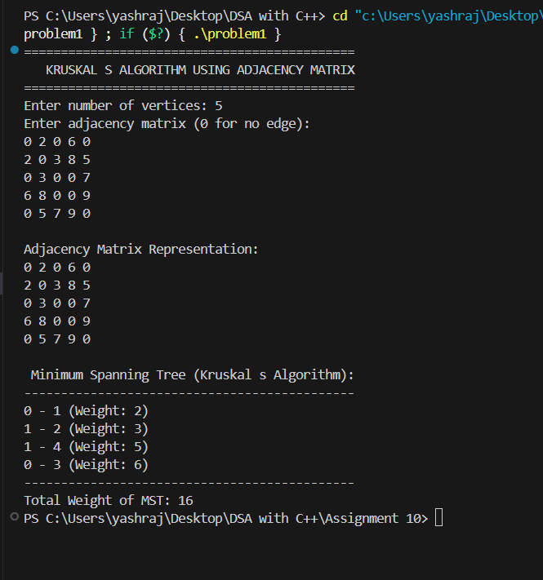

Problem 2: Write a Program to implement Dijkstra’s algorithm to find shortest distance between two nodes of a user defined graph. Use Adjacency Matrix to represent a graph.

CODE:
#include <iostream>
#include <vector>
#include <climits>
using namespace std;

class Graph {
private:
int vertices;
vector<vector<int>> adjMatrix;

public:
// Constructor
Graph(int v) {
vertices = v;
adjMatrix.resize(vertices, vector<int>(vertices, 0));
}

// Accept adjacency matrix from user
void inputGraph() {
cout << "Enter adjacency matrix (0 if no edge):\n";
for (int i = 0; i < vertices; i++) {
for (int j = 0; j < vertices; j++)
cin >> adjMatrix[i][j];
}
}

// Display the adjacency matrix
void displayMatrix() {
cout << "\nAdjacency Matrix Representation:\n";
for (int i = 0; i < vertices; i++) {
for (int j = 0; j < vertices; j++)
cout << adjMatrix[i][j] << " ";
cout << endl;
}
}

// Find the vertex with the minimum distance value
int minDistance(vector<int>& dist, vector<bool>& visited) {
int min = INT_MAX, minIndex = -1;
for (int v = 0; v < vertices; v++) {
if (!visited[v] && dist[v] <= min) {
min = dist[v];
minIndex = v;
}
}
return minIndex;
}

// Dijkstra’s Algorithm
void dijkstra(int src, int dest) {
vector<int> dist(vertices, INT_MAX);
vector<bool> visited(vertices, false);

dist[src] = 0;

for (int count = 0; count < vertices - 1; count++) {
int u = minDistance(dist, visited);
if (u == -1) break; // No more reachable vertices

visited[u] = true;

for (int v = 0; v < vertices; v++) {
if (!visited[v] && adjMatrix[u][v] != 0 && dist[u] != INT_MAX
&& dist[u] + adjMatrix[u][v] < dist[v]) {
dist[v] = dist[u] + adjMatrix[u][v];
}
}
}

cout << "\n Dijkstras Shortest Path Results:\n";
cout << "------------------------------------\n";
for (int i = 0; i < vertices; i++) {
if (dist[i] == INT_MAX)
cout << "Vertex " << i << " : Unreachable\n";
else
cout << "Vertex " << i << " : " << dist[i] << endl;
}

cout << "\nShortest distance from " << src << " to " << dest << " = ";
if (dist[dest] == INT_MAX)
cout << "No path exists.\n";
else
cout << dist[dest] << endl;
}
};

// ================= MAIN FUNCTION =================
int main() {
int v, src, dest;

cout << "==============================================\n";
cout << " DIJKSTRAS ALGORITHM USING ADJACENCY MATRIX\n";
cout << "==============================================\n";

cout << "Enter number of vertices: ";
cin >> v;

Graph g(v);
g.inputGraph();
g.displayMatrix();

cout << "Enter source vertex: ";
cin >> src;
cout << "Enter destination vertex: ";
cin >> dest;

g.dijkstra(src, dest);

return 0;
}

OUTPUT:
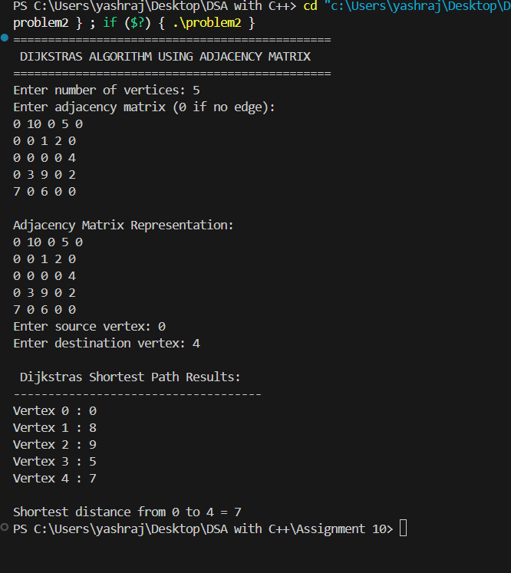

Problem 3 : Write a Program to implement Prim’s algorithm to find minimum spanning tree of a user defined graph. Use Adjacency
List to represent a graph.

CODE:
#include <iostream>
#include <vector>
#include <queue>
#include <utility>
using namespace std;

class Graph {
private:
int vertices;
vector<vector<pair<int, int>>> adj; // pair<vertex, weight>

public:
// Constructor
Graph(int v) {
vertices = v;
adj.resize(vertices);
}

// Function to add edge
void addEdge(int u, int v, int w) {
adj[u].push_back({v, w});
adj[v].push_back({u, w}); // For undirected graph
}

// Prim’s Algorithm
void primMST() {
vector<int> key(vertices, INT8_MAX); // Minimum weight edge for each vertex
vector<int> parent(vertices, -1); // To store MST
vector<bool> inMST(vertices, false); // Included in MST or not

priority_queue<pair<int, int>, vector<pair<int, int>>, greater<pair<int, int>>> pq;

int start = 0;
key[start] = 0;
pq.push({0, start});

while (!pq.empty()) {
int u = pq.top().second;
pq.pop();

if (inMST[u]) continue;
inMST[u] = true;

for (auto &edge : adj[u]) {
int v = edge.first;
int weight = edge.second;

if (!inMST[v] && weight < key[v]) {
key[v] = weight;
pq.push({key[v], v});
parent[v] = u;
}
}
}

cout << "\n Minimum Spanning Tree (Prims Algorithm):\n";
cout << "--------------------------------------------\n";
int totalWeight = 0;
for (int i = 1; i < vertices; i++) {
cout << parent[i] << " - " << i << " (Weight: " << key[i] << ")\n";
totalWeight += key[i];
}
cout << "--------------------------------------------\n";
cout << "Total Weight of MST: " << totalWeight << endl;
}
};

// ================= MAIN FUNCTION =================
int main() {
int v, e;
cout << "==============================================\n";
cout << " PRIMS ALGORITHM USING ADJACENCY LIST\n";
cout << "==============================================\n";

cout << "Enter number of vertices: ";
cin >> v;

Graph g(v);

cout << "Enter number of edges: ";
cin >> e;

cout << "Enter edges (u v weight):\n";
for (int i = 0; i < e; i++) {
int u, v1, w;
cin >> u >> v1 >> w;
g.addEdge(u, v1, w);
}

g.primMST();

return 0;
}

OUTPUT:
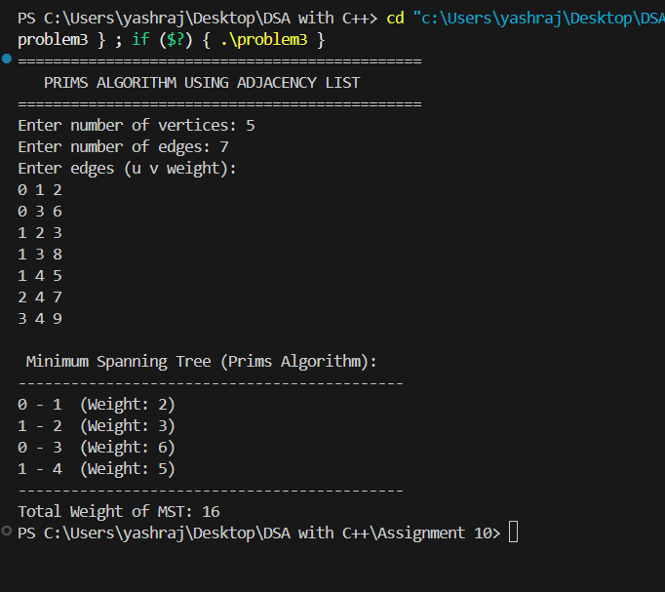

Problem 4 : Write a Program to implement Dijkstra’s algorithm to find shortest distance between two nodes of a user defined graph. Use Adjacency List to represent a graph.

CODE:
#include <iostream>
#include <vector>
#include <algorithm>
using namespace std;

// Structure to represent an edge
struct Edge {
int u, v, weight;
};

// Disjoint Set Union (Union-Find)
class DSU {
vector<int> parent, rank;

public:
DSU(int n) {
parent.resize(n);
rank.resize(n, 0);
for (int i = 0; i < n; i++)
parent[i] = i;
}

int find(int x) {
if (parent[x] != x)
parent[x] = find(parent[x]); // Path compression
return parent[x];
}

void unite(int x, int y) {
int rootX = find(x);
int rootY = find(y);
if (rootX == rootY) return;

if (rank[rootX] < rank[rootY])
parent[rootX] = rootY;
else if (rank[rootX] > rank[rootY])
parent[rootY] = rootX;
else {
parent[rootY] = rootX;
rank[rootX]++;
}
}
};

// Graph Class
class Graph {
private:
int vertices;
vector<vector<pair<int, int>>> adjList;
vector<Edge> edges;

public:
Graph(int v) {
vertices = v;
adjList.resize(vertices);
}

// Add edge (undirected graph)
void addEdge(int u, int v, int w) {
adjList[u].push_back({v, w});
adjList[v].push_back({u, w});
edges.push_back({u, v, w});
}

// Display adjacency list
void displayGraph() {
cout << "\nAdjacency List Representation:\n";
cout << "----------------------------------\n";
for (int i = 0; i < vertices; i++) {
cout << i << " -> ";
for (auto edge : adjList[i])
cout << "(" << edge.first << ", " << edge.second << ") ";
cout << endl;
}
}

// Kruskal’s Algorithm for MST
void kruskalMST() {
sort(edges.begin(), edges.end(), [](Edge a, Edge b) {
return a.weight < b.weight;
});

DSU dsu(vertices);
vector<Edge> result;
int totalWeight = 0;

cout << "\n Minimum Spanning Tree (Kruskals Algorithm):\n";
cout << "---------------------------------------------\n";

for (auto &edge : edges) {
if (dsu.find(edge.u) != dsu.find(edge.v)) {
dsu.unite(edge.u, edge.v);
result.push_back(edge);
totalWeight += edge.weight;
cout << edge.u << " - " << edge.v << " (Weight: " << edge.weight << ")\n";
}
}

cout << "---------------------------------------------\n";
cout << "Total Weight of MST: " << totalWeight << endl;
}
};

// ================= MAIN FUNCTION =================
int main() {
int v, e;
cout << "==============================================\n";
cout << " KRUSKALS ALGORITHM USING ADJACENCY LIST\n";
cout << "==============================================\n";

cout << "Enter number of vertices: ";
cin >> v;

Graph g(v);

cout << "Enter number of edges: ";
cin >> e;

cout << "Enter edges (u v weight):\n";
for (int i = 0; i < e; i++) {
int u, v1, w;
cin >> u >> v1 >> w;
g.addEdge(u, v1, w);
}

g.displayGraph();
g.kruskalMST();

return 0;
}

OUTPUT:
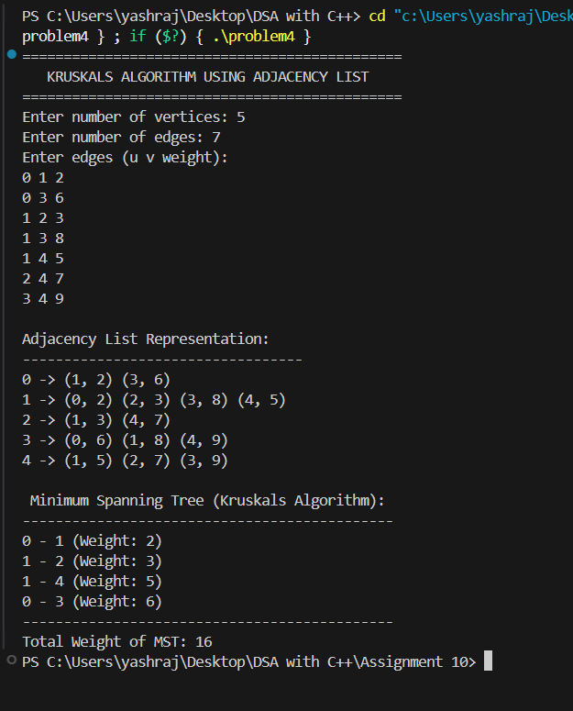

Problem 5 : Write a Program to implement Dijkstra’s algorithm to find shortest distance between two nodes of a user defined graph. Use Adjacency List to represent a graph.
CODE:
#include <iostream>
#include <vector>
#include <queue>
#include <utility>
#include <climits>
using namespace std;

class Graph {
private:
int vertices;
vector<vector<pair<int, int>>> adj; // pair<vertex, weight>

public:
// Constructor
Graph(int v) {
vertices = v;
adj.resize(vertices);
}

// Function to add edge
void addEdge(int u, int v, int w) {
adj[u].push_back({v, w}); // Directed graph (for undirected, add both)
// adj[v].push_back({u, w}); // Uncomment this line for undirected graph
}

// Display adjacency list
void displayGraph() {
cout << "\n Adjacency List Representation:\n";
cout << "----------------------------------\n";
for (int i = 0; i < vertices; i++) {
cout << i << " -> ";
for (auto edge : adj[i])
cout << "(" << edge.first << ", " << edge.second << ") ";
cout << endl;
}
}

// Dijkstra’s Algorithm
void dijkstra(int src, int dest) {
vector<int> dist(vertices, INT_MAX);
priority_queue<pair<int, int>, vector<pair<int, int>>, greater<pair<int, int>>> pq;

dist[src] = 0;
pq.push({0, src});

while (!pq.empty()) {
int u = pq.top().second;
int d = pq.top().first;
pq.pop();

if (d > dist[u]) continue;

for (auto edge : adj[u]) {
int v = edge.first;
int weight = edge.second;

if (dist[u] + weight < dist[v]) {
dist[v] = dist[u] + weight;
pq.push({dist[v], v});
}
}
}

cout << "\n Dijkstras Shortest Path Results:\n";
cout << "------------------------------------\n";
for (int i = 0; i < vertices; i++) {
if (dist[i] == INT_MAX)
cout << "Vertex " << i << " : Unreachable\n";
else
cout << "Vertex " << i << " : " << dist[i] << endl;
}

cout << "\nShortest distance from " << src << " to " << dest << " = ";
if (dist[dest] == INT_MAX)
cout << "No path exists.\n";
else
cout << dist[dest] << endl;
}
};

// ================= MAIN FUNCTION =================
int main() {
int v, e, src, dest;
cout << "==============================================\n";
cout << " DIJKSTRA S ALGORITHM USING ADJACENCY LIST\n";
cout << "==============================================\n";

cout << "Enter number of vertices: ";
cin >> v;

Graph g(v);

cout << "Enter number of edges: ";
cin >> e;

cout << "Enter edges (u v weight):\n";
for (int i = 0; i < e; i++) {
int u, v1, w;
cin >> u >> v1 >> w;
g.addEdge(u, v1, w);
}

g.displayGraph();

cout << "\nEnter source vertex: ";
cin >> src;
cout << "Enter destination vertex: ";
cin >> dest;

g.dijkstra(src, dest);

return 0;
}

OUTPUT:

